Deliverable 2 – Updated Design Document
  - Legendary Team

Written by Yoon-Ho Choi

Disclaimer: Since this document is an extension of the Deliverable1 Design Document, any changes will be written in bold text.
I have patiently waited for my other group members to complete their portion of the deliverable (the UML diagram and Case Diagram), since none of them have completed their portion as of this writing (July 15, 2025: 11:00pm) I will be basing this design document based on my own version of the UML and Use Cases .

(Hello Group Members, please read over this part carefully and delete the following paragraph so that I know you have actually read this document like I asked you to)
I request that my grading be separate from the rest of my group because of their lack of contributions throughout the entire semester and if you are reading this it means that none of my group members have even bothered to read any part of this project.

  - Use Case Narration
- Primary Actor User Starts Game (Main method)
- Secondary Actor WarGame, instantiates 2 players Computer and Player1
- WarGame makes 26 cards and assigns them to Player1
- WarGame makes 26 cards and assigns them to Computer
- User is Prompted to play a card
- User Chooses one card to Play
- Seconary Actor Computer Randomly Picks one card
5.1 Card Values are equal
5.1.1 No points awarded
5.2 Player Card is Higher
5.2.1 Player 1 receives 1 point
5.3 Computer Card is Higher
5.2.2 Computer receives 1 point
6. Repeat 4-5 until all cards are exhausted
7. WarGame checks Both Player Scores
7.1 Player1 score is Higher
7.1.1 Display Message “Player1 Wins”
7.2 Computer score is Higher
7.2.1 Display Message “Computer Wins”
7.3 Scores are Equal
7.3.1 Display Message “It’s a Draw”
UML Diagram
*Multiplicity has not been implemented since this is a rough sketch, I was not responsible for Creating a UML diagram so why should I have to do everything myself.
The arrows used by Visual Paradigm chose Association instead of Aggregation, I don’t know how to change them. I also don’t remember if we discussed Association in class
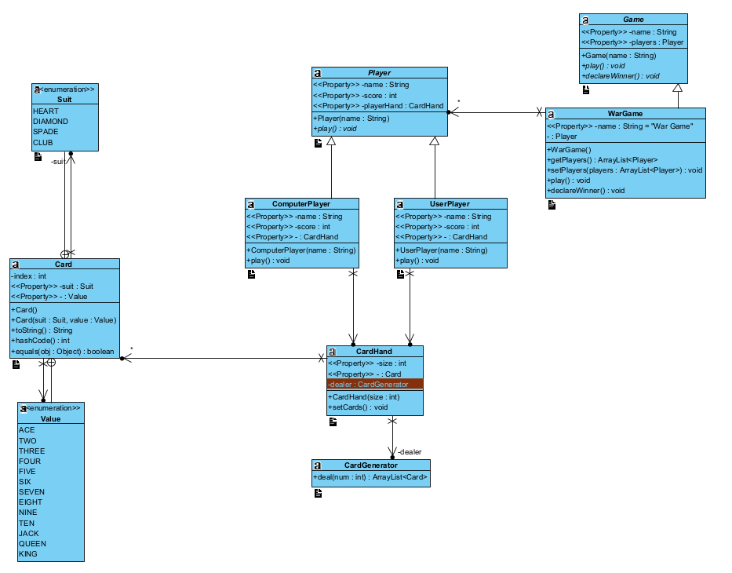
  - CARD
This Card class represents a single playing card in a standard deck.
First the Card class was imported with the objects method. Public enum was declared with the Suit variable with the values HEART, DIAMOND, SPADE, CLUB and public enum was also declared with the Value variable with the values ACE, TWO, THREE, FOUR, FIVE, SIX, SEVEN, EIGHT, NINE, TEN, JACK, QUEEN, KING,
then the Value value and int index variables were declared as private. The public Card(){} was first set with the no args constructor, then public card has the variables Suit suit, Value value with this.suit = suit; and this.value=value; The getter and setter methods were set with the variables getSuit, setSuit,
getValue, and setValue. For starters, the override method was set to public String toString(), then with the return method saying what suit and value are displayed. Secondly the override method was set to public int hashCode() with hash set to 3, hash = 53 * hash + Objects.hashCode(this.suit);
hash = 53 * hash + Objects.hasCode(this.value); return hash; Finally the override method was written with the boolean equals function.
The Starter Code Suggested using Card as an abstract class, I do not understand why this is the case since we want to instantiate card objects for our game, the lack of abstract methods also made the abstract class pointless, I have changed the Card Class to be a regular class instead.
  - CardGenerator
CardGenerator is used to create an ArrayList of Card objects of various sizes.
While it does make reference to the Card class, since it is not a class variable it is a case of association not aggregation.
The CardGenerator class is designed to generate a list of playing cards randomly. First the class is part of the cards package. The public class CardGenerator is responsible for generating all cards.
The method public ArrayList<Card> generateCards (int numCards) generates a number of card objects and returns them in the ArrayList. The method ArrayList<Card> hand = new ArrayList<Card>(); creates a new list to hold the cards like a player’s hand.
The Random rnd = new Random(); creates a random object to generate random numbers. Card.Suit.values returns an array of all suits values (eg. Hearts, Diamonds, etc). Card.Value.values returns an array of all value enums (eg. Ace, 2, 3, King, etc) .length gets the number of options available for suit and value.
The for loop starts a loop that runs numCards times and then creating one new card each time. The int rndSuit and int rndValue generate random integers. c.setValue and c.setSuit randomly assign a value and a suit to a card.
The hand.add(c) adds the generated card to the hand. Finally after the loop the return hand; is returned.
  - CardHand
CardHand is a class used to store an ArrayList of Card objects.
CardHand has both an ArrayList of Cards and a Card Generator as part of its components which therefore means it has an association relationship with these classes.
Note also that the size of Card Hand is not fixed but is instead a parameter, this is for the sake of low coupling, since we want to be able to freely change the size of our hand without having to make changes to other classes.
  - Player (Formerly User)
Player is an abstract class used primarily to store values related to the players involved in the card game.
The class stores values such as: Card hand, Player Score, and Player Name.
Also notably, it uses an abstract method play() which main purpose will be to handle the decisions the user will make throughout the game.
This class makes use of abstraction/inheritance since we will be instantiating different versions of players, such as Human Players, and Computer Players. The difference between these two subclasses will be in the implementation of the play() method, Computer player will choose a card randomly, while Human players are able to choose a card from their hand.
This class does have a bit of low cohesion since it is responsible for more than one role (storing data, and handling player interaction) I would like some feedback on how to adjust this but since you did not bother to give us any feedback for Deliverable 1 I am not expecting anything here either.
The User class is part of a card game simulation in Java. It models a player who has a hand of cards and can receive cards from a dealer. The cards class starts from a package, then java.util.ArrayList is imported.
The public class User represents a player in the game, private ArrayList<Card> hand = new ArrayList<Card>(); this hand stores the cards the player holds, private CardGenerator dealer = new CardGenerator(); this dealer is used to generate the cards for the player.
Next, the getter and setter methods are declared for getHand and setHand. They set the player’s to a given list of cards, the public void startingHand method deals num random cards to the player using the CardGenerator, public void displayHand prints each card in the player’s hand to the console.
  - Game
The Game Abstract Class is used as a template for if we wish to implement other games, it is not very useful for this project since we are only implementing one game but it can be useful as a template.
I think Game would be better implemented as an interface instead of an abstract class since its primary purpose is to be a template I would love some feedback on this.
  - War Game
The WarGame class inherits the properties of Game. It makes full use of the other classes as variables but since it is not instantiated with them it is aggregation not composition, which is better for dependency inversion principles.
Unfortunately, the WarGame class has very low cohesion, it is responsible for Creating Players, Creating CardGenerators and Hands, and Declaring the winner of the game. Feedback on how to fix this would be wonderful.
The multiplicity of the game is currently designed to have 2 players only, but the code can be adjusted relatively easily to include more players, it may be ideal to store the numberOfPlayers as a variable rather than having a fixed number of players for Deliverable3. This would also help with lower coupling.
  - Start (Main Method)
While not included in the diagram, the main method will of course be necessary to run our program.
It will also make use of high cohesion since it will handle only one role, to directly interact with the user.
It also makes full use of abstraction since the user does not need to know how the program will function, everything will be handled by the WarGame class in the background which the user does not need to interact with.
The Start class represents the beginning of a simple card game simulation. The public class Start is commonly used as the driver to start running the program. After the public class the main method begins the execution. User player1 = new User(); creates an object called player1 of type User.
The player1.startingHand(7); function calls the method startingHand() on player1, asking for 7 cards to be dealt. The player1.displayHand(); function calls a method that prints or shows all cards the player has in hand. Finally the System.out.println(“Game Complete”) message is printed.
The UML diagram has the variables Start, User, CardGenerator, Card, Suit, and Value. The Suit and Value variables are both enum. The Card class has the index: int variable and Card with the values suit: Suit and value: Values, the toString method, hashCode method, and equals object with a boolean.
The Start class starts with a main method. The CardGenerator generates cards with the variable numCards: int. Finally the User class has the startingHand and displayHand methods.

